**Development of Network Communication System for Object Localization– An Upgrade**

1. Abstract

The project aims to develop a wireless system for object localization based on the UWB scheme. The previous strategy of setting base stations is to set the positions in the host computer program, then place the base stations to the set positions in the field. The main problem is that there will be an inevitable mismatch between the actual positions of the base stations and the set positions due to manual distance measurements. Our research proposed a new improved method. We arbitrarily place the base stations to the set positions in the field first, then initialize their positions in a computer program by letting base stations themselves measure distances between one another. This method avoids the error from placing base stations so that it can increase the accuracy of the localization system.

1. Introduction of UWB Scheme

UWB positioning technology is a kind of indoor positioning technology, which has the advantages of strong penetration, low power consumption, good anti-multipath effect, high security, low system complexity, and high positioning accuracy. Thus, UWB positioning technology can be applied to indoor positioning tracking and navigation of stationary or moving objects and people and can provide very accurate positioning information.

UWB positioning technology uses TOF (time-of-flight) ranging, which is a two-way ranging technique that uses the time of flight between two transceivers to measure the distance between nodes. The module generates an independent timestamp from the start. The transmitter of module A transmits a pulse signal of request nature at its timestamp a1, and module B transmits a signal of response nature at moment b2, which is received by module A at its own timestamp a2. The equation then calculates the time of flight of the pulse signal between the two modules and thus determines the flight distance. Because the TOF-based range measurement method is linear with distance in a line-of-sight environment, the measurement results will be more accurate.

The list shows the overview of the UWB module used in this project.

|  |  |
| --- | --- |
| YCHIOT UWB Mini 4 module series | |
| Module picture |  |
| Main control chip | STM32F103RCT6 microcontroller |
| Peripheral circuits | DWM1000 module, power module, LED indicator module, reset circuit, etc. |

The following list shows the hardware parameters of the module.

|  |  |  |  |
| --- | --- | --- | --- |
| Basic Parameter | | Wireless Parameter | |
| PCB Craft | 4 layers - epoxy resin | Communication Rate | 110 kbit/s, 850 kbit/s, 6.8 Mbit/s |
| VAB-IO | Micro-USB(5.0V)/connection  column | Operating Frequency | 3.5 GHz ~ 6.5 GHz |
| Communication Interface | Micro - USB (5.0 V)/serial port  (3.3 V TTL) | Work Channel | 6 |
| Download Port | SWD (VCC SDIO SCK  GND) | Transmitting Power | -35dbm/MHZ ~ -62dbm/MHZ |
| Host Controller Driver | STM32F103RCT6(64pin) | Max Packing Length | 1023 bytes |
| External Crystal | 8Mhz | Communication Distance | 30m |
| PCB Size | 35mm * 24mm | Data-dependent Jitter | Typical ±10cm, general occlusion ±30cm |

The indoor positioning function of UWB is very similar to the principle of satellite, that is, by arranging several positioning base stations with known coordinates indoors, the person who needs to locate carries a positioning tag, the tag emits pulses at a certain frequency, continuously ranges with several base stations, and determines the location of the tag through a certain precise algorithm.

3. Mathematical Derivation for a 2-Dimensional Plane

Denote $A_{0}$, $A_{1}$ and $A_{2}$ as base stations, $T_{1}$ is a tag (Fig.1). Through transmission measuring time-delay between UWB modules, we know the distances between pairs of modules, which means the length of $d_{01}$, $d_{02}$, $d_{03}$, $d_{12}$, $d_{13}$, $d_{23}$ are our initial constraints.

Without loss of generality, one can see that $A_{0}$ as the origin and the line $A_{0}A_{1}$ lies on the X-axis. Consequently, the coordinates of $A_{0}$ are (0, 0), the coordinate of $A_{1}$ is (0, $d_{01}$).

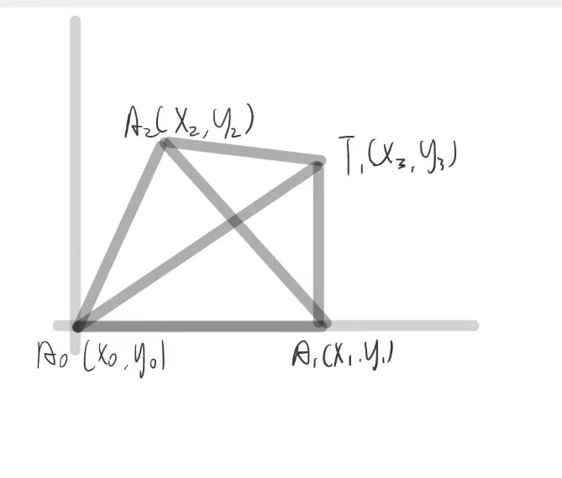

Figure 1.

First, we know that

$$\begin{aligned}d_{01}^{2}=x_{1}^{2}\#\left( AUTONUM \backslash * Arabic \right)\end{aligned}$$

$$\begin{aligned}d_{02}^{2}=x_{2}^{2}+y_{2}^{2}\#\left( AUTONUM \backslash * Arabic \right)\end{aligned}$$

$$\begin{aligned}d_{03}^{2}=x_{3}^{2}+y_{3}^{2}\#\left( AUTONUM \backslash * Arabic \right)\end{aligned}$$

$$\begin{aligned}d_{12}^{2}={\left(x_{2}-x_{1}\right)}^{2}+y_{2}^{2}\#\left( AUTONUM \backslash * Arabic \right)\end{aligned}$$

$$\begin{aligned}d_{23}^{2}={\left(x_{3}-x_{2}\right)}^{2}+{\left(y_{3}-y_{2}\right)}^{2}\#\left( AUTONUM \backslash * Arabic \right)\end{aligned}$$

$$\begin{aligned}d_{13}^{2}={\left(x_{3}-x_{1}\right)}^{2}+y_{3}^{2}\#\left( AUTONUM \backslash * Arabic \right)\end{aligned}$$

After elimination, one obtains

$$\begin{aligned}d_{12}^{2}=d_{02}^{2}-2x_{1}x_{2}+d_{01}^{2}\#\left(1\right)\end{aligned}$$

$$\begin{aligned}d_{13}^{2}=d_{03}^{2}-2x_{1}x_{3}+d_{01}^{2}\#\left(2\right)\end{aligned}$$

Since $x_{1}=d_{01}$, the remaining coordinates are given by $$\begin{aligned}x_{2}=\frac{d_{01}^{2}+d_{02}^{2}-d_{12}^{2}}{2d_{01}}\#\left(1\right)\end{aligned}$$

$$\begin{aligned}x_{3}=\frac{d_{01}^{2}+d_{03}^{2}-d_{13}^{2}}{2d_{01}}\#\left(2\right)\end{aligned}$$

$$\begin{aligned}y_{2}=\sqrt{d_{02}^{2}-{\left(\frac{d_{01}^{2}+d_{02}^{2}-d_{12}^{2}}{2d_{01}}\right)}^{2}}\#\left(3\right)\end{aligned}$$

$$\begin{aligned}y_{3}=\sqrt{d_{03}^{2}-{\left(\frac{d_{01}^{2}+d_{03}^{2}-d_{13}^{2}}{2d_{01}}\right)}^{2}}\#\left(4\right)\end{aligned}$$

Note that there are 6 measurements ($d_{01}^{2}=x_{1}^{2}$, $d_{02}^{2}=x_{2}^{2}+y_{2}^{2}$, $d_{03}^{2}=x_{3}^{2}+y_{3}^{2}$, $d_{12}^{2}={\left(x_{2}-x_{1}\right)}^{2}+y_{2}^{2}$, $d_{23}^{2}={\left(x_{3}-x_{2}\right)}^{2}+{\left(y_{3}-y_{2}\right)}^{2}$, $d_{13}^{2}={\left(x_{3}-x_{1}\right)}^{2}+y_{3}^{2}$) but only 5 variables ($x_{1}$, $x_{2}$, $y_{2}$, $x_{3}$, $y_{3}$). The extra measurement can be generally applied to estimate a smaller number of variables by minimizing the estimation error:

Given $d_{01}$, $d_{02}$, $d_{03}$, $d_{12}$, $d_{13}$, $d_{23}$

Estimate $x_{1}$, $x_{2}$, $x_{3}$, $y_{2}$, $y_{3}$

Define difference function

$$G(x,y)=D-d=\left[\begin{aligned}x_{1}-d_{01} \\ \sqrt{x_{2}^{2}+y_{2}^{2}}-d_{02} \\ \sqrt{x_{3}^{2}+y_{3}^{2}}-d_{03} \\ \sqrt{{\left(x_{2}-x_{1}\right)}^{2}+y_{2}^{2}}-d_{12} \\ \sqrt{{\left(x_{3}-x_{1}\right)}^{2}+y_{3}^{2}}-d_{13} \\ \sqrt{{\left(x_{3}-x_{2}\right)}^{2}+{\left(y_{3}-y_{2}\right)}^{2}}-d_{23}\end{aligned}\right]$$

We might now define the objective function

$$F\left(x,y\right)=\frac{1}{2}G^{T}\left(x,y\right)G\left(x,y\right)=\frac{1}{2}[{\left(x_{1}-d_{01}\right)}^{2}+{(\sqrt{x_{2}^{2}+y_{2}^{2}}-d_{02})}^{2}+{(\sqrt{x_{3}^{2}+y_{3}^{2}}-d_{03})}^{2}+{(\sqrt{{\left(x_{2}-x_{1}\right)}^{2}+y_{2}^{2}}-d_{12})}^{2}+{(\sqrt{{\left(x_{3}-x_{1}\right)}^{2}+y_{3}^{2}}-d_{13})}^{2}+{(\sqrt{{\left(x_{3}-x_{2}\right)}^{2}+{\left(y_{3}-y_{2}\right)}^{2}}-d_{23})}^{2}]$$

Which we will attempt to minimize. As an initial guess, let us use the calculation above which is in an ideal state:

$${(x,y)}^{(0)}=\left[\begin{aligned}d_{01} \\ \frac{d_{01}^{2}+d_{02}^{2}-d_{12}^{2}}{2d_{01}} \\ \frac{d_{01}^{2}+d_{03}^{2}-d_{13}^{2}}{2d_{01}} \\ \sqrt{d_{02}^{2}-{(\frac{d_{01}^{2}+d_{02}^{2}-d_{12}^{2}}{2d_{01}})}^{2}} \\ \sqrt{d_{03}^{2}-{(\frac{d_{01}^{2}+d_{03}^{2}-d_{13}^{2}}{2d_{01}})}^{2}}\end{aligned}\right]$$

Applying the scheme of steepest descent, the new estimate is given by

$${(x,y)}^{(1)}={(x,y)}^{(0)}-γ_{0}∇F\left(0,0\right)={(x,y)}^{(0)}-γ_{0}J_{G}(0,0)G(0,0)$$

Where $γ_{0}$ is for the learning rate and the Jacobian matrix $J_{G}$ is given by

$\left[\begin{matrix}2(x_{1}-d_{01}) & 0 & 0 & \frac{-2(\sqrt{{\left(x_{2}-x_{1}\right)}^{2}+y_{2}^{2}}-d_{12})\left(x_{2}-x_{1}\right)}{\sqrt{{\left(x_{2}-x_{1}\right)}^{2}+y_{2}^{2}}} & \frac{-2(\sqrt{{\left(x_{3}-x_{1}\right)}^{2}+y_{3}^{2}}-d_{13})\left(x_{3}-x_{1}\right)}{\sqrt{{\left(x_{3}-x_{1}\right)}^{2}+y_{3}^{2}}} & 0 \\ 0 & \frac{{2(\sqrt{x_{2}^{2}+y_{2}^{2}}-d_{02})x}_{2}}{\sqrt{x_{2}^{2}+y_{2}^{2}}} & 0 & \frac{2(\sqrt{{\left(x_{2}-x_{1}\right)}^{2}+y_{2}^{2}}-d_{12})\left(x_{2}-x_{1}\right)}{\sqrt{{\left(x_{2}-x_{1}\right)}^{2}+y_{2}^{2}}} & 0 & \frac{-2(\sqrt{{\left(x_{3}-x_{2}\right)}^{2}+{\left(y_{3}-y_{2}\right)}^{2}}-d_{23})\left(x_{3}-x_{2}\right)}{\sqrt{{\left(x_{3}-x_{2}\right)}^{2}+{\left(y_{3}-y_{2}\right)}^{2}}} \\ 0 & 0 & \frac{{2(\sqrt{x_{3}^{2}+y_{3}^{2}}-d_{03})x}_{3}}{\sqrt{x_{3}^{2}+y_{3}^{2}}} & 0 & \frac{2(\sqrt{{\left(x_{3}-x_{1}\right)}^{2}+y_{3}^{2}}-d_{13})\left(x_{3}-x_{1}\right)}{\sqrt{{\left(x_{3}-x_{1}\right)}^{2}+y_{2}^{2}}} & \frac{2(\sqrt{{\left(x_{3}-x_{2}\right)}^{2}+{\left(y_{3}-y_{2}\right)}^{2}}-d_{23})\left(x_{3}-x_{2}\right)}{\sqrt{{\left(x_{3}-x_{2}\right)}^{2}+{\left(y_{3}-y_{2}\right)}^{2}}} \\ 0 & \frac{2(\sqrt{x_{2}^{2}+y_{2}^{2}}-d_{02})y_{2}}{\sqrt{x_{2}^{2}+y_{2}^{2}}} & 0 & \frac{2(\sqrt{{\left(x_{2}-x_{1}\right)}^{2}+y_{2}^{2}}-d_{12})y_{2}}{\sqrt{{\left(x_{2}-x_{1}\right)}^{2}+y_{2}^{2}}} & 0 & \frac{-2(\sqrt{{\left(x_{3}-x_{2}\right)}^{2}+{\left(y_{3}-y_{2}\right)}^{2}}-d_{23})\left(y_{3}-y_{2}\right)}{\sqrt{{\left(x_{3}-x_{2}\right)}^{2}+{\left(y_{3}-y_{2}\right)}^{2}}} \\ 0 & 0 & \frac{2(\sqrt{x_{3}^{2}+y_{3}^{2}}-d_{03})y_{3}}{\sqrt{x_{3}^{2}+y_{3}^{2}}} & 0 & \frac{{2(\sqrt{{\left(x_{3}-x_{1}\right)}^{2}+y_{3}^{2}}-d_{13})y}_{3}}{\sqrt{{\left(x_{3}-x_{1}\right)}^{2}+y_{2}^{2}}} & \frac{2(\sqrt{{\left(x_{3}-x_{2}\right)}^{2}+{\left(y_{3}-y_{2}\right)}^{2}}-d_{23})\left(y_{3}-y_{2}\right)}{\sqrt{{\left(x_{3}-x_{2}\right)}^{2}+{\left(y_{3}-y_{2}\right)}^{2}}}\end{matrix}\right]$

We calculate

$J_{G}\left(0,0\right)=\left[\begin{matrix}0 & 0 & 0 & 0 & 0 & 0 \\ 0 & 0 & 0 & 0 & 0 & \frac{-2(\sqrt{d_{02}^{2}+d_{03}^{2}-2\frac{d_{01}^{2}+d_{02}^{2}-d_{12}^{2}}{2d_{01}}\frac{d_{01}^{2}+d_{03}^{2}-d_{13}^{2}}{2d_{01}}-2\sqrt{d_{02}^{2}-{(\frac{d_{01}^{2}+d_{02}^{2}-d_{12}^{2}}{2d_{01}})}^{2}}\sqrt{d_{03}^{2}-{(\frac{d_{01}^{2}+d_{03}^{2}-d_{13}^{2}}{2d_{01}})}^{2}}}-d_{23})\left(\frac{d_{01}^{2}+d_{03}^{2}-d_{13}^{2}}{2d_{01}}-\frac{d_{01}^{2}+d_{02}^{2}-d_{12}^{2}}{2d_{01}}\right)}{\sqrt{d_{02}^{2}+d_{03}^{2}-2\frac{d_{01}^{2}+d_{02}^{2}-d_{12}^{2}}{2d_{01}}\frac{d_{01}^{2}+d_{03}^{2}-d_{13}^{2}}{2d_{01}}-2\sqrt{d_{02}^{2}-{(\frac{d_{01}^{2}+d_{02}^{2}-d_{12}^{2}}{2d_{01}})}^{2}}\sqrt{d_{03}^{2}-{(\frac{d_{01}^{2}+d_{03}^{2}-d_{13}^{2}}{2d_{01}})}^{2}}}-d_{23}} \\ 0 & 0 & 0 & 0 & 0 & \frac{2(\sqrt{d_{02}^{2}+d_{03}^{2}-2\frac{d_{01}^{2}+d_{02}^{2}-d_{12}^{2}}{2d_{01}}\frac{d_{01}^{2}+d_{03}^{2}-d_{13}^{2}}{2d_{01}}-2\sqrt{d_{02}^{2}-{(\frac{d_{01}^{2}+d_{02}^{2}-d_{12}^{2}}{2d_{01}})}^{2}}\sqrt{d_{03}^{2}-{(\frac{d_{01}^{2}+d_{03}^{2}-d_{13}^{2}}{2d_{01}})}^{2}}}-d_{23})\left(\frac{d_{01}^{2}+d_{03}^{2}-d_{13}^{2}}{2d_{01}}-\frac{d_{01}^{2}+d_{02}^{2}-d_{12}^{2}}{2d_{01}}\right)}{\sqrt{d_{02}^{2}+d_{03}^{2}-2\frac{d_{01}^{2}+d_{02}^{2}-d_{12}^{2}}{2d_{01}}\frac{d_{01}^{2}+d_{03}^{2}-d_{13}^{2}}{2d_{01}}-2\sqrt{d_{02}^{2}-{(\frac{d_{01}^{2}+d_{02}^{2}-d_{12}^{2}}{2d_{01}})}^{2}}\sqrt{d_{03}^{2}-{(\frac{d_{01}^{2}+d_{03}^{2}-d_{13}^{2}}{2d_{01}})}^{2}}}-d_{23}} \\ 0 & 0 & 0 & 0 & 0 & \frac{-2(\sqrt{d_{02}^{2}+d_{03}^{2}-2\frac{d_{01}^{2}+d_{02}^{2}-d_{12}^{2}}{2d_{01}}\frac{d_{01}^{2}+d_{03}^{2}-d_{13}^{2}}{2d_{01}}-2\sqrt{d_{02}^{2}-{(\frac{d_{01}^{2}+d_{02}^{2}-d_{12}^{2}}{2d_{01}})}^{2}}\sqrt{d_{03}^{2}-{(\frac{d_{01}^{2}+d_{03}^{2}-d_{13}^{2}}{2d_{01}})}^{2}}}-d_{23})\left(\sqrt{d_{03}^{2}-{(\frac{d_{01}^{2}+d_{03}^{2}-d_{13}^{2}}{2d_{01}})}^{2}}-\sqrt{d_{02}^{2}-{(\frac{d_{01}^{2}+d_{02}^{2}-d_{12}^{2}}{2d_{01}})}^{2}}\right)}{\sqrt{d_{02}^{2}+d_{03}^{2}-2\frac{d_{01}^{2}+d_{02}^{2}-d_{12}^{2}}{2d_{01}}\frac{d_{01}^{2}+d_{03}^{2}-d_{13}^{2}}{2d_{01}}-2\sqrt{d_{02}^{2}-{(\frac{d_{01}^{2}+d_{02}^{2}-d_{12}^{2}}{2d_{01}})}^{2}}\sqrt{d_{03}^{2}-{(\frac{d_{01}^{2}+d_{03}^{2}-d_{13}^{2}}{2d_{01}})}^{2}}}-d_{23}} \\ 0 & 0 & 0 & 0 & 0 & \frac{2(\sqrt{d_{02}^{2}+d_{03}^{2}-2\frac{d_{01}^{2}+d_{02}^{2}-d_{12}^{2}}{2d_{01}}\frac{d_{01}^{2}+d_{03}^{2}-d_{13}^{2}}{2d_{01}}-2\sqrt{d_{02}^{2}-{(\frac{d_{01}^{2}+d_{02}^{2}-d_{12}^{2}}{2d_{01}})}^{2}}\sqrt{d_{03}^{2}-{(\frac{d_{01}^{2}+d_{03}^{2}-d_{13}^{2}}{2d_{01}})}^{2}}}-d_{23})\left(\sqrt{d_{03}^{2}-{(\frac{d_{01}^{2}+d_{03}^{2}-d_{13}^{2}}{2d_{01}})}^{2}}-\sqrt{d_{02}^{2}-{(\frac{d_{01}^{2}+d_{02}^{2}-d_{12}^{2}}{2d_{01}})}^{2}}\right)}{\sqrt{d_{02}^{2}+d_{03}^{2}-2\frac{d_{01}^{2}+d_{02}^{2}-d_{12}^{2}}{2d_{01}}\frac{d_{01}^{2}+d_{03}^{2}-d_{13}^{2}}{2d_{01}}-2\sqrt{d_{02}^{2}-{(\frac{d_{01}^{2}+d_{02}^{2}-d_{12}^{2}}{2d_{01}})}^{2}}\sqrt{d_{03}^{2}-{(\frac{d_{01}^{2}+d_{03}^{2}-d_{13}^{2}}{2d_{01}})}^{2}}}-d_{23}}\end{matrix}\right]$

$G\left(0,0\right)=\left[\begin{aligned}0 \\ 0 \\ 0 \\ 0 \\ 0 \\ \sqrt{d_{02}^{2}+d_{03}^{2}-2\frac{d_{01}^{2}+d_{02}^{2}-d_{12}^{2}}{2d_{01}}\frac{d_{01}^{2}+d_{03}^{2}-d_{13}^{2}}{2d_{01}}-2\sqrt{d_{02}^{2}-{(\frac{d_{01}^{2}+d_{02}^{2}-d_{12}^{2}}{2d_{01}})}^{2}}\sqrt{d_{03}^{2}-{(\frac{d_{01}^{2}+d_{03}^{2}-d_{13}^{2}}{2d_{01}})}^{2}}}-d_{23}\end{aligned}\right]$

Thus

${(x,y)}^{(1)}=\left[\begin{aligned}d_{01} \\ \frac{d_{01}^{2}+d_{02}^{2}-d_{12}^{2}}{2d_{01}} \\ \frac{d_{01}^{2}+d_{03}^{2}-d_{13}^{2}}{2d_{01}} \\ \sqrt{d_{02}^{2}-{(\frac{d_{01}^{2}+d_{02}^{2}-d_{12}^{2}}{2d_{01}})}^{2}} \\ \sqrt{d_{03}^{2}-{(\frac{d_{01}^{2}+d_{03}^{2}-d_{13}^{2}}{2d_{01}})}^{2}}\end{aligned}\right]-γ_{0}\left[\begin{matrix}0 & 0 & 0 & 0 & 0 & 0 \\ 0 & 0 & 0 & 0 & 0 & \frac{-2(\sqrt{d_{02}^{2}+d_{03}^{2}-2\frac{d_{01}^{2}+d_{02}^{2}-d_{12}^{2}}{2d_{01}}\frac{d_{01}^{2}+d_{03}^{2}-d_{13}^{2}}{2d_{01}}-2\sqrt{d_{02}^{2}-{(\frac{d_{01}^{2}+d_{02}^{2}-d_{12}^{2}}{2d_{01}})}^{2}}\sqrt{d_{03}^{2}-{(\frac{d_{01}^{2}+d_{03}^{2}-d_{13}^{2}}{2d_{01}})}^{2}}}-d_{23})\left(\frac{d_{01}^{2}+d_{03}^{2}-d_{13}^{2}}{2d_{01}}-\frac{d_{01}^{2}+d_{02}^{2}-d_{12}^{2}}{2d_{01}}\right)}{\sqrt{d_{02}^{2}+d_{03}^{2}-2\frac{d_{01}^{2}+d_{02}^{2}-d_{12}^{2}}{2d_{01}}\frac{d_{01}^{2}+d_{03}^{2}-d_{13}^{2}}{2d_{01}}-2\sqrt{d_{02}^{2}-{(\frac{d_{01}^{2}+d_{02}^{2}-d_{12}^{2}}{2d_{01}})}^{2}}\sqrt{d_{03}^{2}-{(\frac{d_{01}^{2}+d_{03}^{2}-d_{13}^{2}}{2d_{01}})}^{2}}}-d_{23}} \\ 0 & 0 & 0 & 0 & 0 & \frac{2(\sqrt{d_{02}^{2}+d_{03}^{2}-2\frac{d_{01}^{2}+d_{02}^{2}-d_{12}^{2}}{2d_{01}}\frac{d_{01}^{2}+d_{03}^{2}-d_{13}^{2}}{2d_{01}}-2\sqrt{d_{02}^{2}-{(\frac{d_{01}^{2}+d_{02}^{2}-d_{12}^{2}}{2d_{01}})}^{2}}\sqrt{d_{03}^{2}-{(\frac{d_{01}^{2}+d_{03}^{2}-d_{13}^{2}}{2d_{01}})}^{2}}}-d_{23})\left(\frac{d_{01}^{2}+d_{03}^{2}-d_{13}^{2}}{2d_{01}}-\frac{d_{01}^{2}+d_{02}^{2}-d_{12}^{2}}{2d_{01}}\right)}{\sqrt{d_{02}^{2}+d_{03}^{2}-2\frac{d_{01}^{2}+d_{02}^{2}-d_{12}^{2}}{2d_{01}}\frac{d_{01}^{2}+d_{03}^{2}-d_{13}^{2}}{2d_{01}}-2\sqrt{d_{02}^{2}-{(\frac{d_{01}^{2}+d_{02}^{2}-d_{12}^{2}}{2d_{01}})}^{2}}\sqrt{d_{03}^{2}-{(\frac{d_{01}^{2}+d_{03}^{2}-d_{13}^{2}}{2d_{01}})}^{2}}}-d_{23}} \\ 0 & 0 & 0 & 0 & 0 & \frac{-2(\sqrt{d_{02}^{2}+d_{03}^{2}-2\frac{d_{01}^{2}+d_{02}^{2}-d_{12}^{2}}{2d_{01}}\frac{d_{01}^{2}+d_{03}^{2}-d_{13}^{2}}{2d_{01}}-2\sqrt{d_{02}^{2}-{(\frac{d_{01}^{2}+d_{02}^{2}-d_{12}^{2}}{2d_{01}})}^{2}}\sqrt{d_{03}^{2}-{(\frac{d_{01}^{2}+d_{03}^{2}-d_{13}^{2}}{2d_{01}})}^{2}}}-d_{23})\left(\sqrt{d_{03}^{2}-{(\frac{d_{01}^{2}+d_{03}^{2}-d_{13}^{2}}{2d_{01}})}^{2}}-\sqrt{d_{02}^{2}-{(\frac{d_{01}^{2}+d_{02}^{2}-d_{12}^{2}}{2d_{01}})}^{2}}\right)}{\sqrt{d_{02}^{2}+d_{03}^{2}-2\frac{d_{01}^{2}+d_{02}^{2}-d_{12}^{2}}{2d_{01}}\frac{d_{01}^{2}+d_{03}^{2}-d_{13}^{2}}{2d_{01}}-2\sqrt{d_{02}^{2}-{(\frac{d_{01}^{2}+d_{02}^{2}-d_{12}^{2}}{2d_{01}})}^{2}}\sqrt{d_{03}^{2}-{(\frac{d_{01}^{2}+d_{03}^{2}-d_{13}^{2}}{2d_{01}})}^{2}}}-d_{23}} \\ 0 & 0 & 0 & 0 & 0 & \frac{2(\sqrt{d_{02}^{2}+d_{03}^{2}-2\frac{d_{01}^{2}+d_{02}^{2}-d_{12}^{2}}{2d_{01}}\frac{d_{01}^{2}+d_{03}^{2}-d_{13}^{2}}{2d_{01}}-2\sqrt{d_{02}^{2}-{(\frac{d_{01}^{2}+d_{02}^{2}-d_{12}^{2}}{2d_{01}})}^{2}}\sqrt{d_{03}^{2}-{(\frac{d_{01}^{2}+d_{03}^{2}-d_{13}^{2}}{2d_{01}})}^{2}}}-d_{23})\left(\sqrt{d_{03}^{2}-{(\frac{d_{01}^{2}+d_{03}^{2}-d_{13}^{2}}{2d_{01}})}^{2}}-\sqrt{d_{02}^{2}-{(\frac{d_{01}^{2}+d_{02}^{2}-d_{12}^{2}}{2d_{01}})}^{2}}\right)}{\sqrt{d_{02}^{2}+d_{03}^{2}-2\frac{d_{01}^{2}+d_{02}^{2}-d_{12}^{2}}{2d_{01}}\frac{d_{01}^{2}+d_{03}^{2}-d_{13}^{2}}{2d_{01}}-2\sqrt{d_{02}^{2}-{(\frac{d_{01}^{2}+d_{02}^{2}-d_{12}^{2}}{2d_{01}})}^{2}}\sqrt{d_{03}^{2}-{(\frac{d_{01}^{2}+d_{03}^{2}-d_{13}^{2}}{2d_{01}})}^{2}}}-d_{23}}\end{matrix}\right]\left[\begin{aligned}0 \\ 0 \\ 0 \\ 0 \\ 0 \\ \sqrt{d_{02}^{2}+d_{03}^{2}-2\frac{d_{01}^{2}+d_{02}^{2}-d_{12}^{2}}{2d_{01}}\frac{d_{01}^{2}+d_{03}^{2}-d_{13}^{2}}{2d_{01}}-2\sqrt{d_{02}^{2}-{(\frac{d_{01}^{2}+d_{02}^{2}-d_{12}^{2}}{2d_{01}})}^{2}}\sqrt{d_{03}^{2}-{(\frac{d_{01}^{2}+d_{03}^{2}-d_{13}^{2}}{2d_{01}})}^{2}}}-d_{23}\end{aligned}\right]$

can be calculated.

$$F\left(0,0\right)=\frac{1}{2}G^{T}\left(x,y\right)G\left(x,y\right)$$

Now, a suitable $γ_{0}$ must be found such that

$$F\left({(x,y)}^{(1)}\right)≤F\left({\left(x,y\right)}^{\left(0\right)}\right)=F(0,0)$$

This can be done with any of a variety of line search algorithms. One might also simply guess a $γ_{0}$, which gives ${(x,y)}^{(1)}$.

Evaluating the objective function at this value, yields $F\left({(x,y)}^{(1)}\right)$

This procedure is repeated until the set of best estimates that minimizes $F\left(x,y\right)$  is obtained.

1. Research Progress

4.1. Process of the New Scheme

(a). Measure the distance among 3 base stations using the UWB time-delay scheme. Denote $A_{0}$, $A_{1}$, $A_{2}$ as 3 base stations. Assume that the coordinate of $A_{0}$ is $\left(0,0\right)$, the coordinate of $A_{1}$ is $\left(x_{1},0\right)$, the coordinate of $A_{2}$ is $\left(x_{2},y_{2}\right)$. So, we have 3 variables and 3 distances as constraints.

(b). Add a tag to reduce the error. Assume that the coordinate of tag $T_{0}$ is $\left(x_{3},y_{3}\right)$, So, we have 2 more variables and 3 more constraints. Use the method in the previous report to calculate the best estimates.

(c). Move the tag to another place and repeat the operation of (b). Each time we add the data to the calculation and get a set of 3 distances among base stations as a result. After several times, we get more data and make the matrix larger, until we find the results converge. So, we get more accurate distances. Compare with the initial measurement result in (a), we can also get the error.

3.2. Regulation of Distance Measurements between a Pair of UWB Modules

(a). Components Setting

Set Base stations and tags as Figure 2.

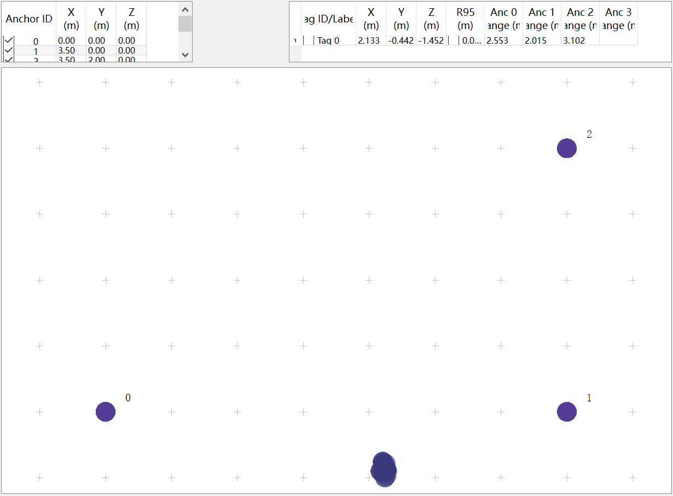

Figure 2. Placement of base stations and tags.

(b). Experiment Results and Analyzations

(1). The tag was set in $(2,0)$. So, the distance between $A_{0}$ and $T_{0}$ is 2 meters. Through the output, we can find that the x coordinate of the tag is about 2.1 m. Considering the error in putting base stations and tags, the accuracy seems to be acceptable.

However, through data, we can find that the measuring distance between $A_{0}$ and $T_{0}$ is about 2.5m. So, we can conclude that the program did an optimization using the distances between $A_{0}$ and $T_{0}$, $A_{1}$ and $T_{0}$, $A_{2}$ and $T_{0}$. So, the performance of our module is not so good. Simply using a base and a tag to measure the distance between them will cause a big error.

Data that are shown in Figure 3 also prove that.

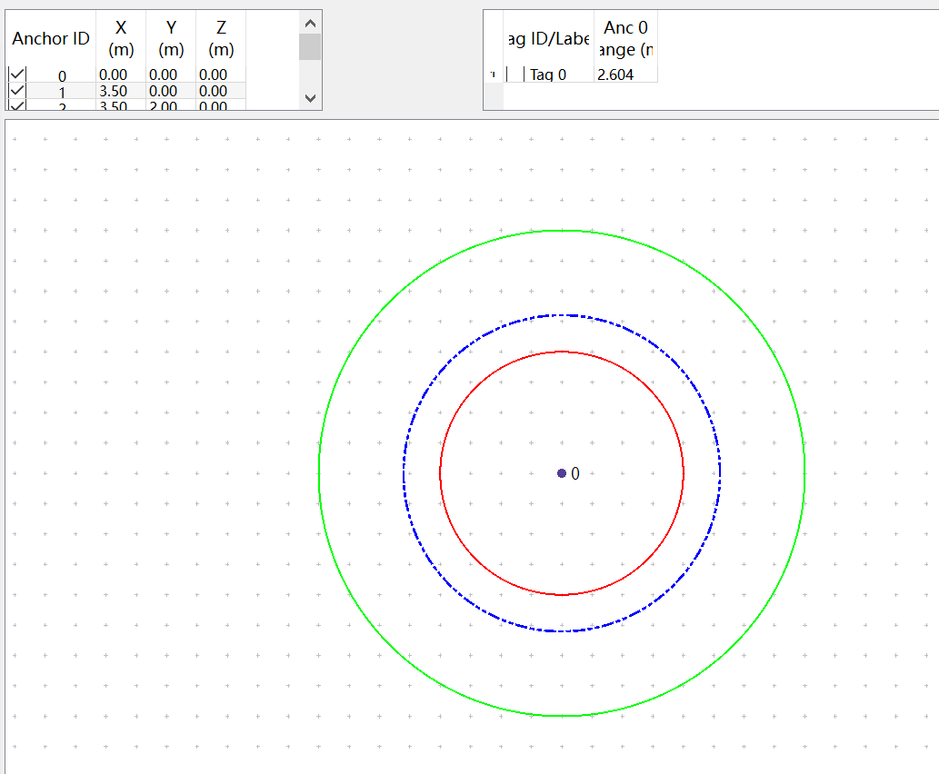

Figure 3. Distance between $A_{0}$ and $T_{0}$.

(2). Then we recorded the distances between $A_{0}$ and $T_{0}$, both real distance measured in tape ($R$) and distance measured by UWB modules ($M$). The data are as follows:

|  |  |
| --- | --- |
| $$R$$ | $$M$$ |
| 0.5 | 0.8~0.9 |
| 1 | 1.5~1.6 |
| 1.5 | 2~2.1 |
| 2 | 2.5~2.6 |
| 2.5 | 3~3.1 |
| 3 | 3.6 |
| 3.5 | 4.2 |
| 4 | 4.6~4.7 |
| 4.5 | 5~5.1 |
| 5 | 5.6~5.7 |

Draw function graph as Figure 4.

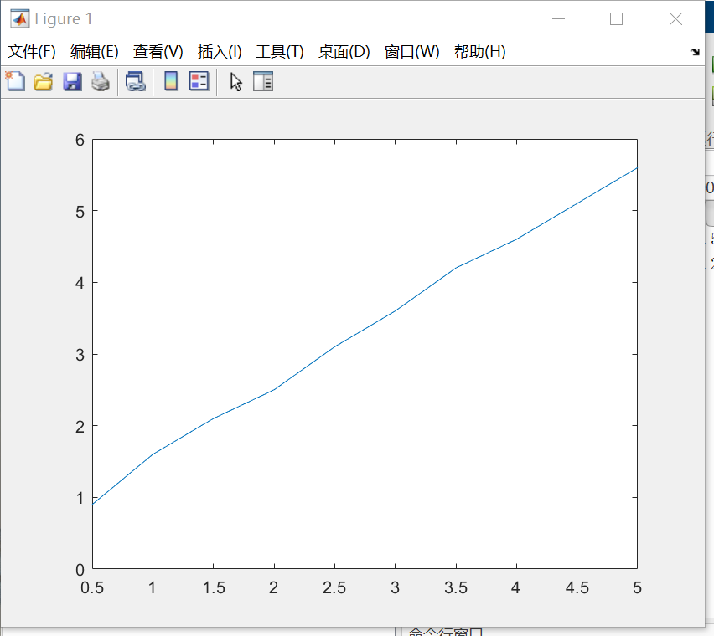

Figure 4.

Linear model Poly1:

f(x) = p1*x + p2

Coefficients (with 95% confidence bounds):

p1 =1 (0.9812, 1.019)

p2 =0.6 (0.5416, 0.6584)

Goodness of fit:

SSE: 0.01101

R-square: 0.9995

Adjusted R-square: 0.9994

RMSE: 0.0371

So, we can get $f\left(x\right)=x+0.6$. Hence the distances estimated by time-delay are consistently 0.6 m longer than those measured.

* 1. Serial Port Output Data Analysis

To implement the new scheme, we need to design new programs using the raw data of UWB modules. We chose the situation that contained 3 base stations and 2 tags.

(a). Components Setting

Set Base stations and tags as Figure 5.

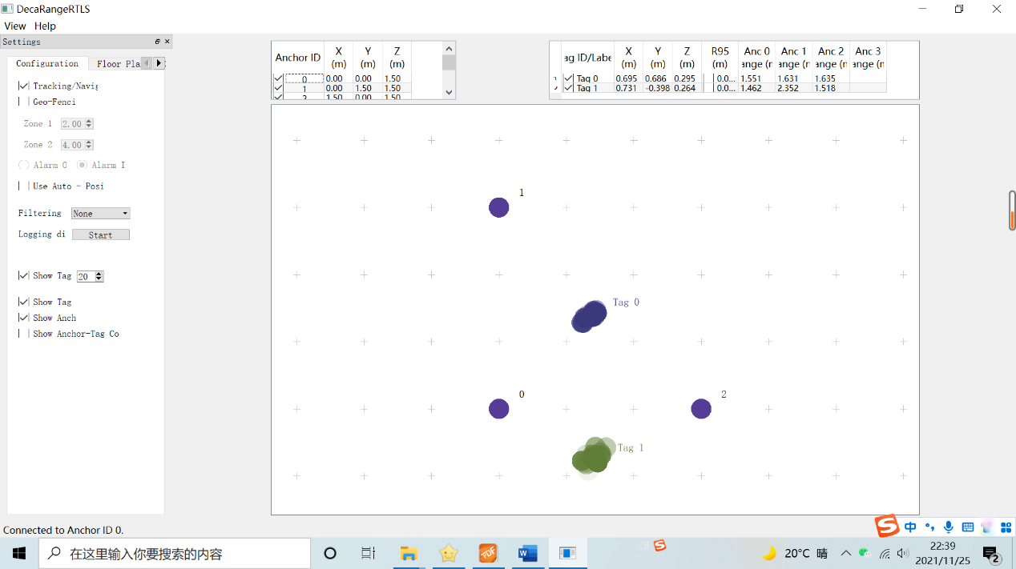

Figure 5. Placement of base stations and tags.

Three base stations $A_{0}$ (0,0), $A_{1}$ (0,1500), $A_{2}$ (1500,0), and two tags $T_{0}$ (750,750), $T_{1}$ (750,0) （Unit: mm）

Theoretical value of distances：

$A_{0}T_{0}$ = $A_{1}T_{0}$ = $A_{2}T_{0}$ = $\sqrt{{750}^{2}+{750}^{2}}≈$ 1061, after plus offset 600mm, it became 1661.

$A_{0}T_{1}$ = $A_{2}T_{1}$ =750, after plus offset 600mm, it became 1350.

$A_{1}T_{1}$ = $\sqrt{{750}^{2}+{1500}^{2}}≈$ 1677, after plus offset 600mm, it became 2277.

$A_{0}A_{0}$ =0.

$A_{0}A_{1}$ = $A_{0}A_{2}$ =1500, after plus offset 600mm, it became 2100.

(b). Recording of Serial Port Output Data and Analysis

Here we show a part of output data.

ma 0e 00000000 00000817 0000084b 00000b17 1695 89 00010d7e a0:0

mc 07 0000060a 00000634 00000655 00000000 1698 de 00010d8c a0:0

mc 07 000005bb 00000947 000005e5 00000000 169b ec 00010d95 a1:0

ma 0e 00000000 00000809 00000859 00000b04 169e 8a 00010de2 a0:0

mc 07 00000618 00000655 0000066d 00000000 16a1 df 00010df0 a0:0

mc 07 00000634 00000947 0000062b 00000000 16a4 ed 00010df9 a1:0

ma 0e 00000000 00000838 00000846 00000b09 16a7 8b 00010e46 a0:0

mc 07 00000618 00000663 00000671 00000000 16aa e0 00010e54 a0:0

mc 07 0000059e 00000939 000005e9 00000000 16ad ee 00010e5d a1:0

ma 0e 00000000 00000820 00000846 00000b0e 16b0 8c 00010eaa a0:0

mc 07 00000622 00000647 00000655 00000000 16b3 e1 00010eb8 a0:0

mc 07 000005f3 00000951 00000622 00000000 16b6 ef 00010ec1 a1:0

ma 0e 00000000 00000838 00000859 00000b12 16b9 8d 00010f0e a0:0

mc 07 00000630 00000639 0000065a 00000000 16bc e2 00010f1c a0:0

mc 07 000005e9 00000939 0000060f 00000000 16bf f0 00010f25 a1:0

ma 0e 00000000 00000812 00000841 00000aed 16c2 8e 00010f72 a0:0

mc 07 00000614 0000065a 00000643 00000000 16c5 e3 00010f80 a0:0

mc 07 000005bb 00000930 000005f7 00000000 16c8 f1 00010f89 a1:0

ma 0e 00000000 00000812 00000859 00000afb 16cb 8f 00010fd6 a0:0

mc 07 00000618 00000630 00000643 00000000 16ce e4 00010fe4 a0:0

mc 07 000005e5 00000939 00000606 00000000 16d1 f2 00010fed a1:0

ma 0e 00000000 0000081c 0000084f 00000b04 16d4 90 0001103a a0:0

mc 07 0000061d 00000647 0000065f 00000000 16d7 e5 00011048 a0:0

mc 07 000005e9 0000093e 000005f3 00000000 16da f3 00011051 a1:0

ma 0e 00000000 00000817 0000084b 00000b04 16dd 91 0001109e a0:0

mc 07 00000634 00000626 00000655 00000000 16e0 e6 000110ac a0:0

mc 07 00000601 00000943 00000601 00000000 16e3 f4 000110b5 a1:0

ma 0e 00000000 00000812 0000082a 00000ae3 16e6 92 00011102 a0:0

mc 07 0000060a 00000668 00000663 00000000 16e9 e7 00011110 a0:0

mc 07 000005d7 00000939 00000647 00000000 16ec f5 00011119 a1:0

The explanation of the output data is as follows:

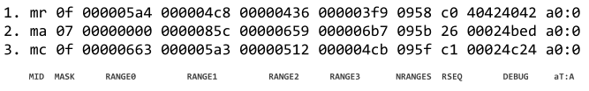

|  |  |
| --- | --- |
| Content | Function |
| MID | Message-ID, there are three types, respectively mr, mc, ma.  mc stands for tag - base station distance.  mr stands for tag - base station distance optimized by filter (the filter is not given).  ma stands for base station - base station distance. |
| MASK | Represent which messages are valid, e.g., MASK=7(0000 0111) represents RANGE0, RANGE1, RANGE2 are valid. |
| RANGE0 | If MID =mc, represents the distance from tag X to base station 0, in mm (the maximum distance in mm that can be represented in 8 HEX digits is 4294967295, same hereinafter).  If MID =ma, represents the distance from the base station 0 to base station 0, in mm. |
| RANGE1 | If MID =mc, represents the distance from tag X to base station 1, in mm.  If MID =ma, represents the distance from the base station 0 to base station 1, in mm. |
| RANGE2 | If MID =mc, represents the distance from tag X to base station 2, in mm.  If MID =ma, represents the distance from the base station 0 to base station 2, in mm. |
| RANGE3 | If MID =mc, represents the distance from tag X to base station 3, in mm.  If MID =ma, represents the distance from the base station 0 to base station 3, in mm. |
| NRANGES | Unit raw range, a count value, will add up over time. |
| RSEQ | Range sequence value, a count value, will add up over time. |
| DEBUG | If MID=MA, represents TX/RX antenna delay. |
| aT:A | T is the tag ID and A is the base station ID  The ID mentioned here is only a short ID; the full ID is a 64-bit ID |

Mean:

$A_{0}A_{1}$:2076.2 $A_{0}A_{2}$:2122.3

$A_{0}T_{0}$:1584.3 $A_{1}T_{0}$:1607.5 $A_{2}T_{0}$:1625.5

$A_{0}T_{1}$:1490.6 $A_{1}T_{1}$:2366.8 $A_{2}T_{1}$:1545.8

1. Discussion

Overall, we have proposed a new scheme of UWB localization and proved it mathematically. We also implemented the regulation of distance measurements and tried to do the positioning using data directly output by the UWB modules. The next step will be developing a computer program, including a GUI interface to calculate and show the results intuitively.

Also, Professor Wong proposed a new idea that we can dynamically obtain the coordinates of UWB modules, which means there is no difference between base stations and anchor, the position of robots in a stable space will be obtained by themselves measuring the distances between one another, while the robots are still moving. We can consider this idea after completing the work of this phase.